\*\*VOID does not return a value 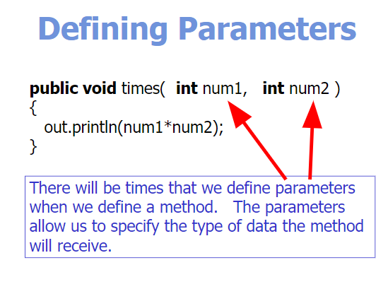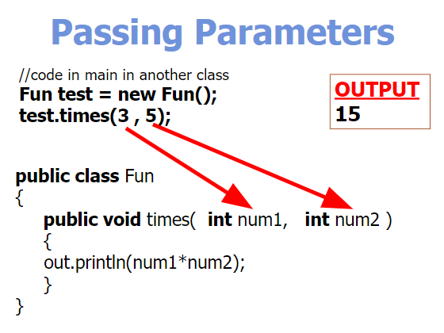

\*\*Order of the parameters does matter (if you have multiple data types)